Sarah Worley

April 27, 2025

CIT 21200

TJ Kane

Links

GitHub Pages Link: <https://srworley.github.io/final_project/>

GitHub Repository: <https://github.com/srworley/final_project>

Wireframes

Home Page:

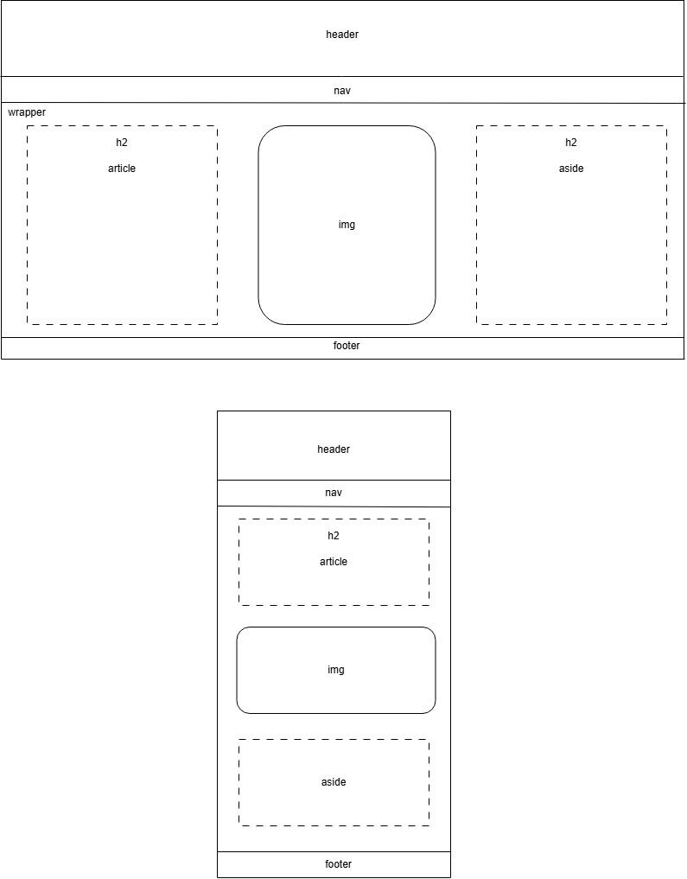

Additional Two Pages:

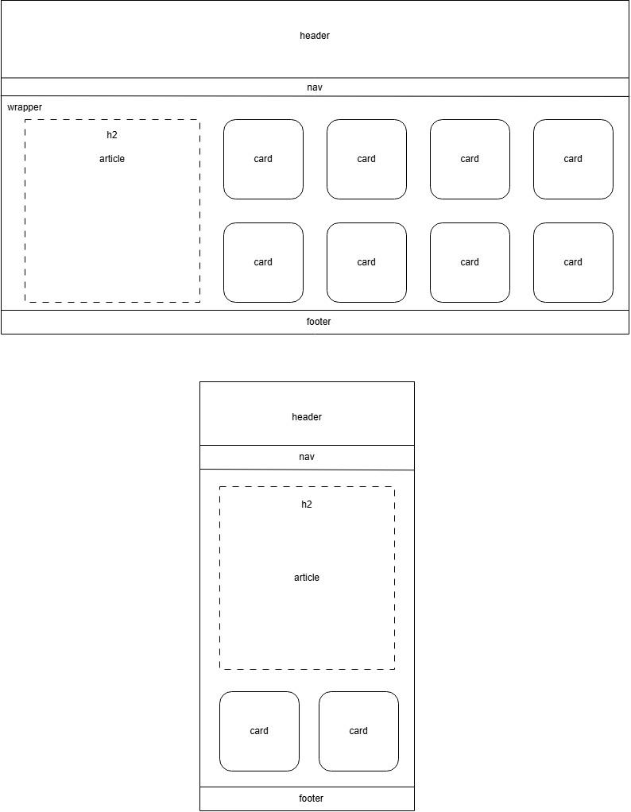

Style Descriptions Chart

| **Style Rule** | **Description** |
| --- | --- |
| body {  margin: 0px;  } | Removes border from the webpage |
| header {  width: 100%;  height: 150px;  background-color: #591202;  padding-top: 50px;  position: relative;  } | Width and Height control proportions  Background-color controls the color of the background of the element  Padding-top adds padding to the top between the content and border  Position: relative positions the element relative to the other elements on the page |
| h1 {  font-family: 'Times New Roman', Times, serif;  text-align: center;  color: #a87c24;  position: relative;  } | Font-family controls the font  Text-align controls where the text appears within the element  Color controls the color of the text |
| nav a {  text-decoration: none;  color: #DCD6CE;  padding-left: 75px;  padding-right: 75px;  font-weight: bold;  } | Text-decoration controls how the link appears before and after it is selected  Font-weight controls the weight of the text |
| .wrapper {  width: 100%;  height: 520px;  display: flex;  flex-direction: row;  flex-wrap: wrap;  position: relative;  background-color: #ccbeac;  } | Display: flex gives the element flex properties  Flex-direction means the elements appear in a row rather than a column  Flex-wrap controls how the elements overflow from the container element |
| article {  width: 355px;  height: 420px;  background-color: #a77064;  color: #260101;  font-family: 'Times New Roman', Times, serif;  position: absolute;  top: 25px;  left: 25px;  padding: 30px;  } | Top and left rules control the displacement of the element compared to its default position |
| .img {  width: 355px;  height: 480px;  position: absolute;  top: 25px;  left: 475px;  background-image: url(hera.jpg);  background-size: cover;  background-repeat: no-repeat;  } | Background-img determines the image that will appear in the background of the element  Background-size ensures the image will cover the whole element  Background-repeat controls whether or not the image is repeated if there is extra space |
| .card {  width: 150px;  height: 150px;  border-radius: 15px;  border: 3px solid #260101;  background-repeat: no-repeat;  background-size: cover;  background-image: url("hera.jpg");  margin: 15px;  } | Border-radius causes the corners of the element to appear rounded  Border sets the style of the element’s border  Margin controls the space beyond the border of the element |
| footer {  width: 100%;  height: 30px;  background-color: #591202;  color:#DCD6CE;  text-align: center;  font-family: 'Times New Roman', Times, serif;  padding-top: 15px;  bottom: 0px;  } | Bottom sets the displacement from the bottom of the screen |
| @media screen and (max-width: 1200px) {  } | Governs how the elements on the page appear when the width is within certain boundaries |